3K04 Pacemaker Project

DCM Documentation

October 10, 2019

Contents

Introduction 3

Main Flowchart 4

Modules 4

Application 4

GUI 5

GUI Controller 5

GUI Abstraction Layer 5

GUI Library 5

Data Management 5

User Data Manager 5

User Account Manager 5

Database Manager 5

SQLite ORM Library 5

SQLite Database 5

Pacemaker Communication 5

Pacemaker Communication Manger 5

Serial Library 5

# Introduction

# Main Flowchart

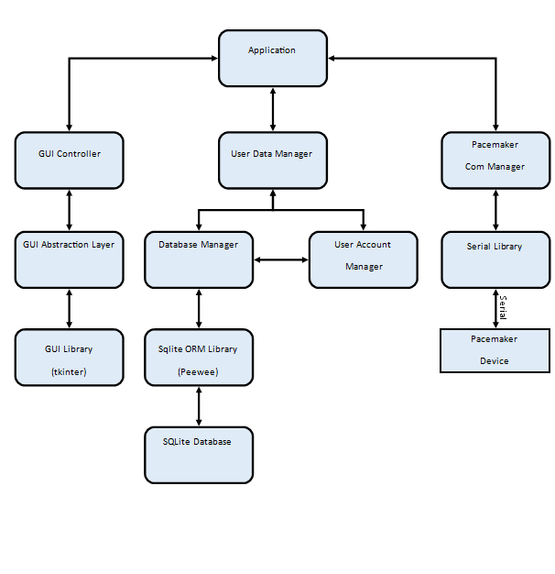

# Modules

## Application

#### Description:

Main Application module, starts GUI, and handles transmission of data between modules.

## GUI

### GUI Controller

#### **Description**

The GUI Controller handles the drawing of our custom interface to the display, by calling our GUI Library through the GUI Abstraction Layer. The GUI Controller takes care of such tasks as starting menus, filling forms with values, and building the GUI.

#### **Public Functions**

#### **Private Functions**

#### **Black Box Behaviour**

#### **Global Variables**

#### **Function Descriptions**

### GUI Abstraction Layer

### GUI Library

## Data Management

### User Data Manager

### User Account Manager

### Database Manager

### SQLite ORM Library

### SQLite Database

## Pacemaker Communication

### Pacemaker Communication Manger

### Serial Library